Test Yourself - The Cell Cycle and Mitosis
- Which type of cells within our bodies use mitosis to reproduce?
- Does mitosis create a cell that is different or the identical to the parent cell undergoing division?
- Describe the DNA found in sister chromatids.
- Describe the DNA found in homologous chromosomes.
- What occurs during the following stages of the cell cycle?
  - G₁ Phase
  - S Phase
  - G₂ Phase
  - M Phase
- What are the phases of mitosis? What events occur in each phase? (To best understand these processes, draw the phases in order and provide a brief description of cellular events at each stage.)
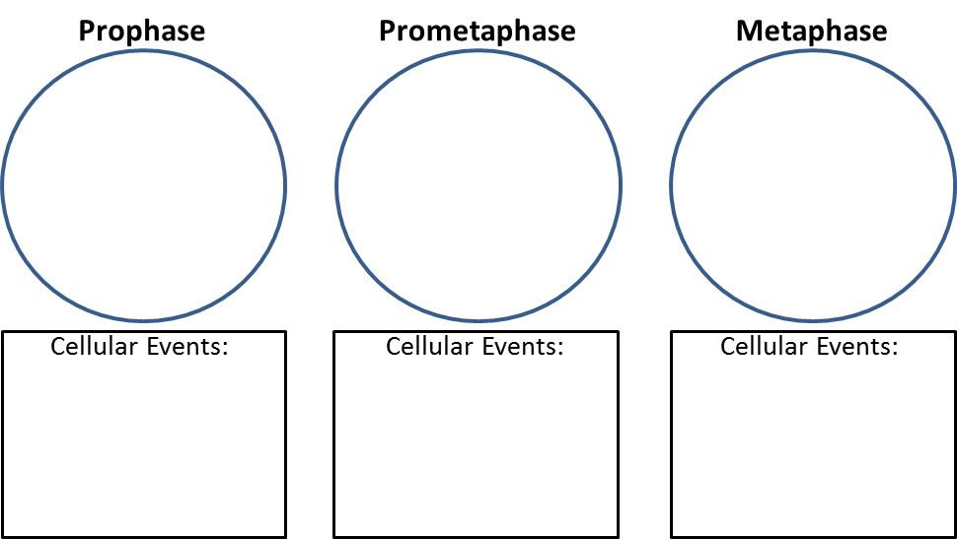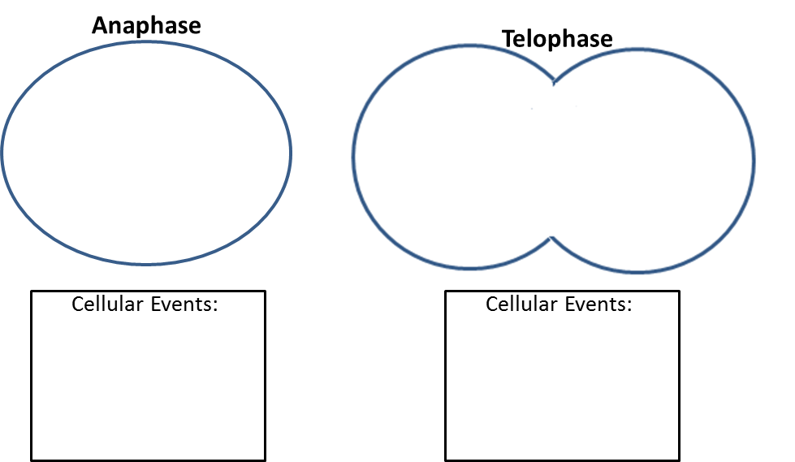

- Does mitosis separate homologous chromosomes, sister chromatids, or both?
- What is cytokinesis?
- Which fibers of the cytoskeleton contract to pinch parent and daughter cells apart from one another in animals?
- How do microtubules move chromosomes to the two poles of a dividing cell?
- How are centrioles involved in this process?
- How do plants form two complete cells during cytokinesis?
- How do bacterial cells reproduce?
- The cell cycle is controlled at “checkpoints”. What occurs at each of the following checkpoints?
- G₁ Checkpoint
- G₂ Checkpoint
- M Checkpoint
- How do cyclin and cdk act to control the G2 checkpoint?
- If presented with the schematic of the M checkpoint, you should be able to explain perturbations to the system as well as if the cell will divide or stall at metaphase.
- Cancerous cells form when the cell cycle checkpoints do not function correctly and a continues to divide even though it is damaged in some way. How does the protein p53 function to keep these cells from dividing?
- Normal cells follow certain rules of growth that cancerous cells do not follow. What are these rules (provide a short definition for each as well)?
- What is the difference between a benign tumor and a malignant tumor?

